

IBM DATA ANALYTICS ASSIGNMENT - 3

**Name: LAVISH YADAV**

**Mail id:**lavish. [21bce7046@vitapstudent.ac.in](mailto:21bce7046@vitapstudent.ac.in)

**Lecturer Name: Indra Sir**

While let us use the MY SQL for the connectivity for that we have create a data base named as (super data)

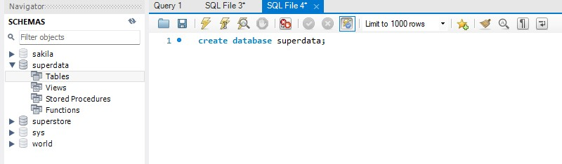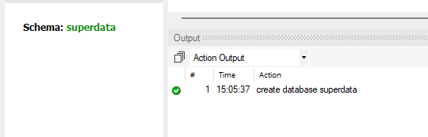

After creating the data now we have to insert the give data set into it

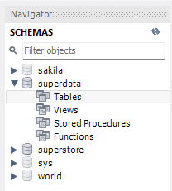

Now we have to insert the data in the tables in the table data import wizard

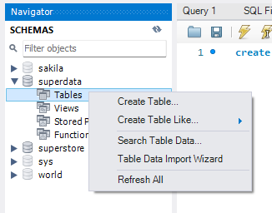

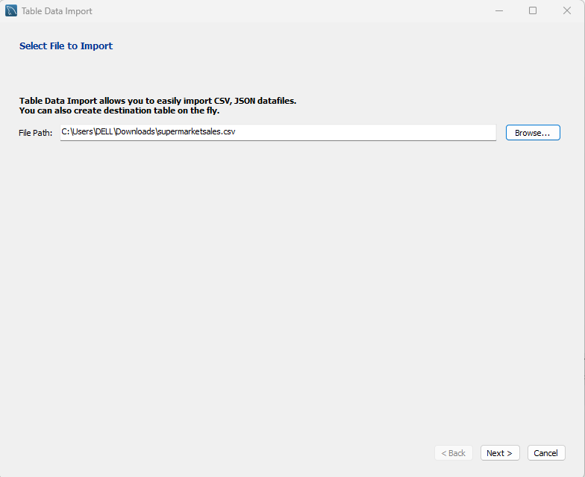

It will come after inserting the data

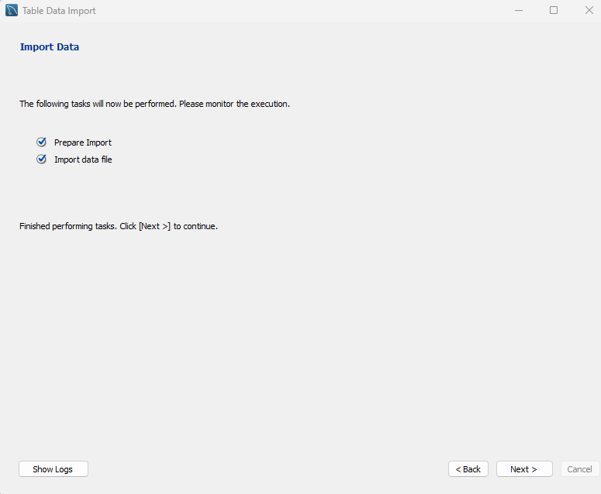

Our table was inserted

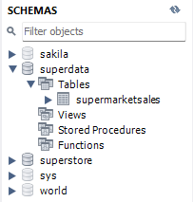

Now connect the tableau with the MY SQL server

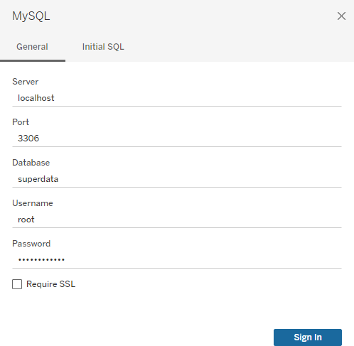

After filling these details sign in and our tableau worksheet will ready

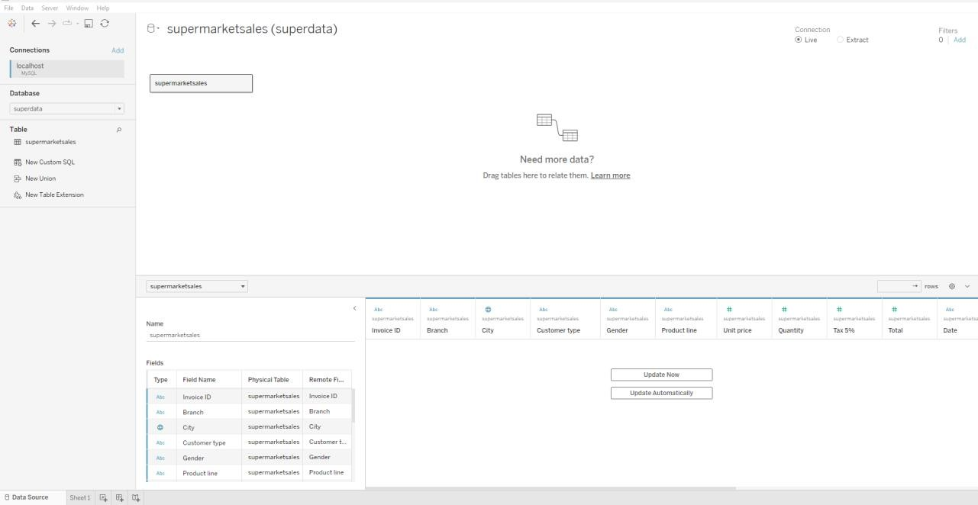

Now let create the visualizations by using this tableau software

1. Bar Chart:

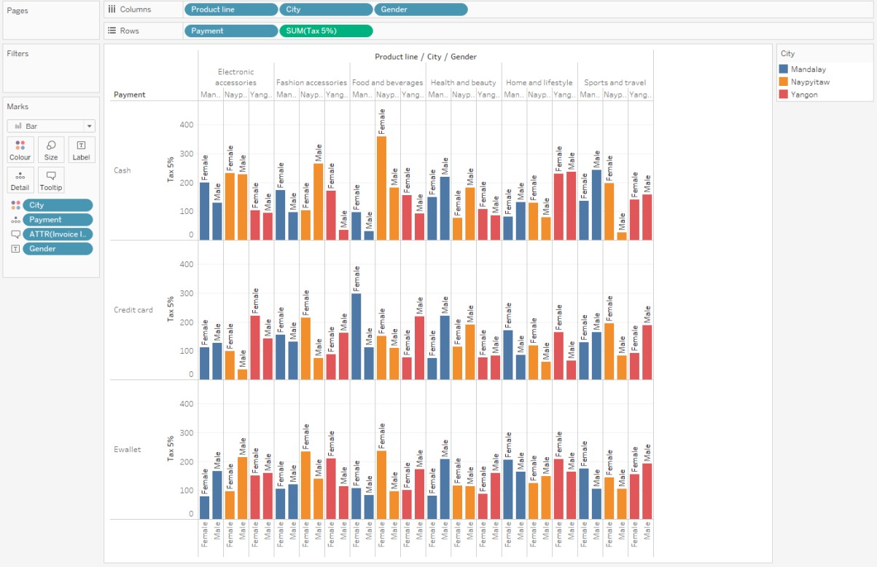

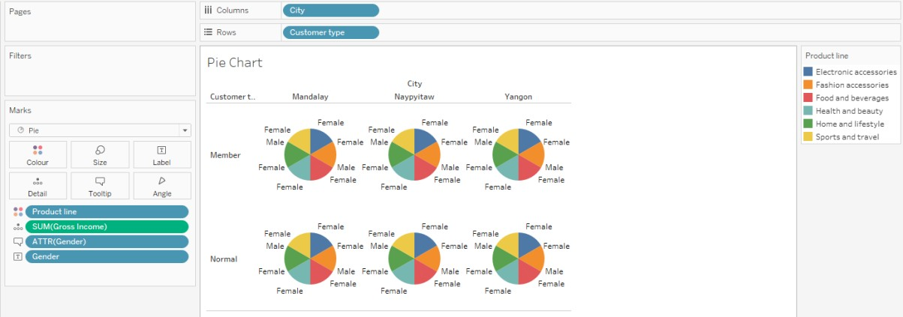

3. Stacked bar chart:

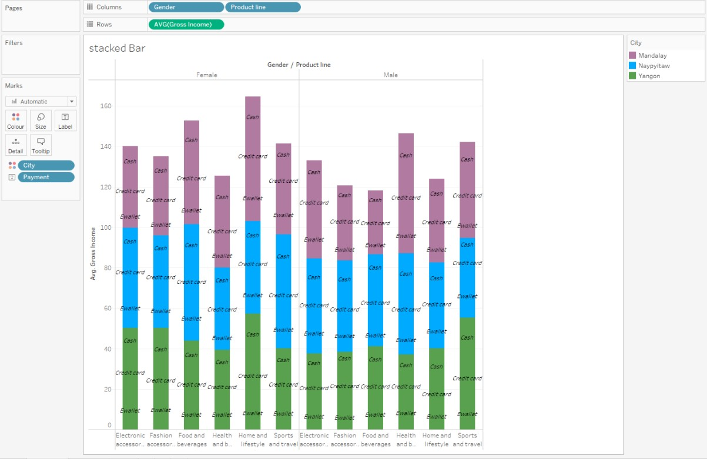

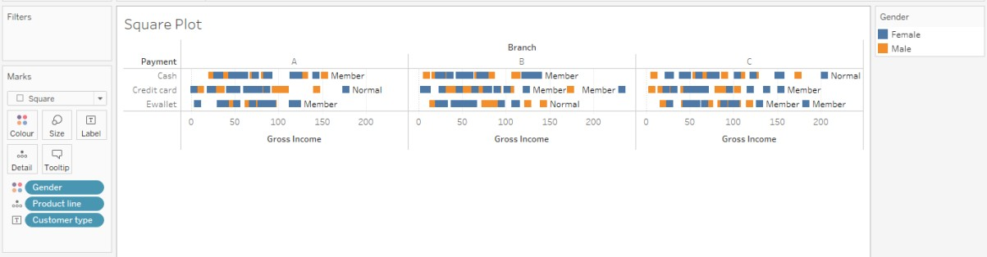

5. Line Chart:

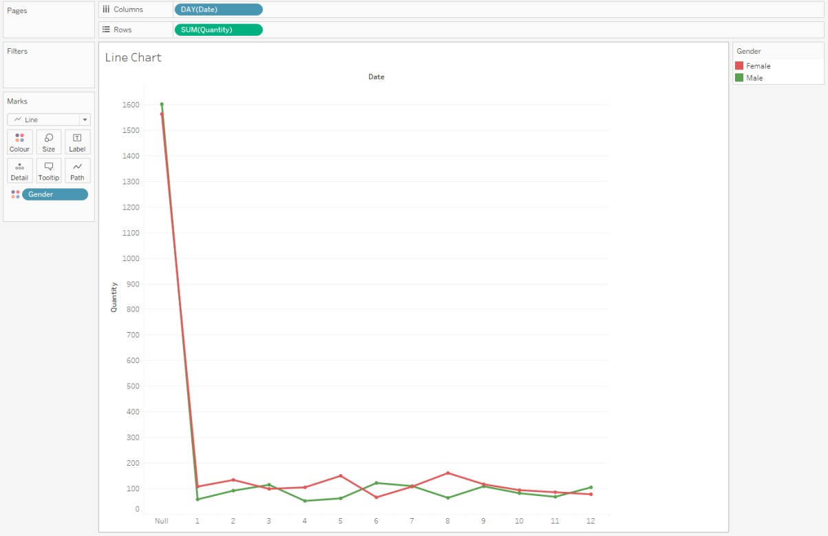

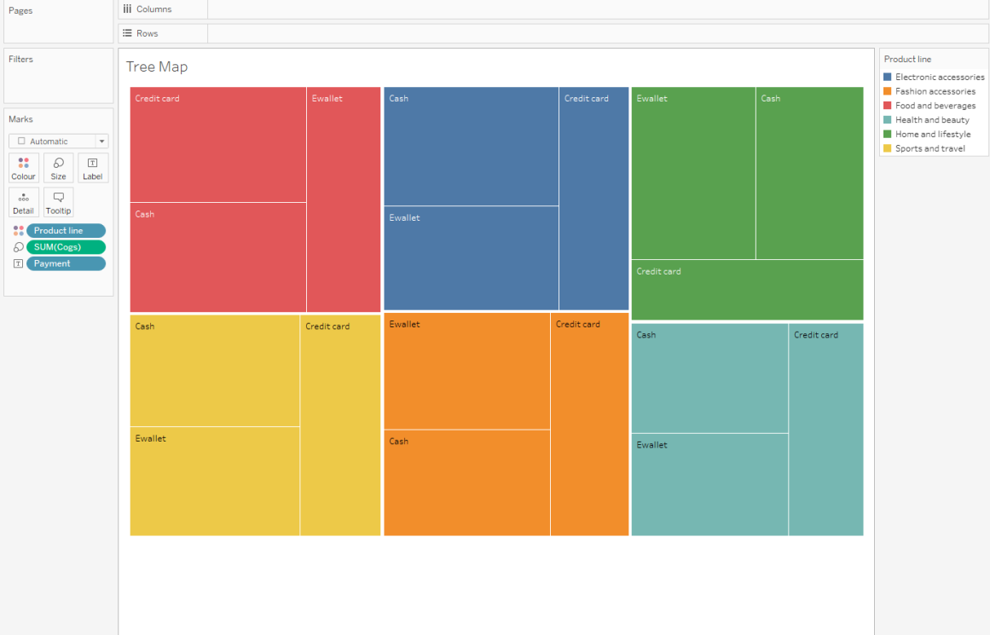

7. Circle Chart:

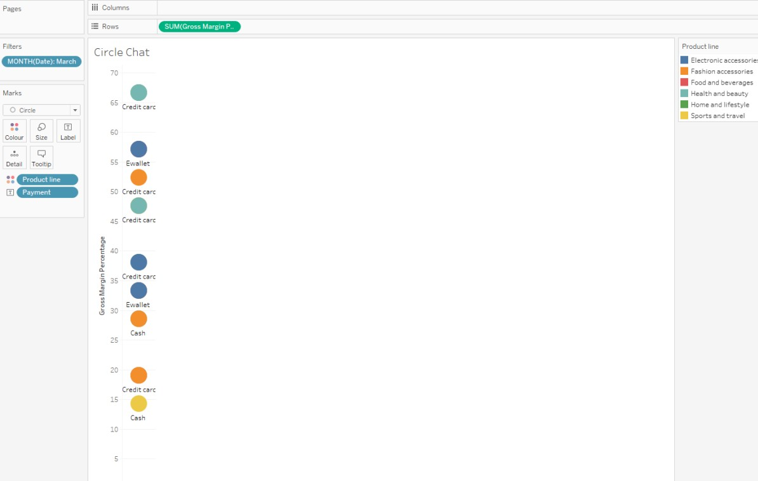

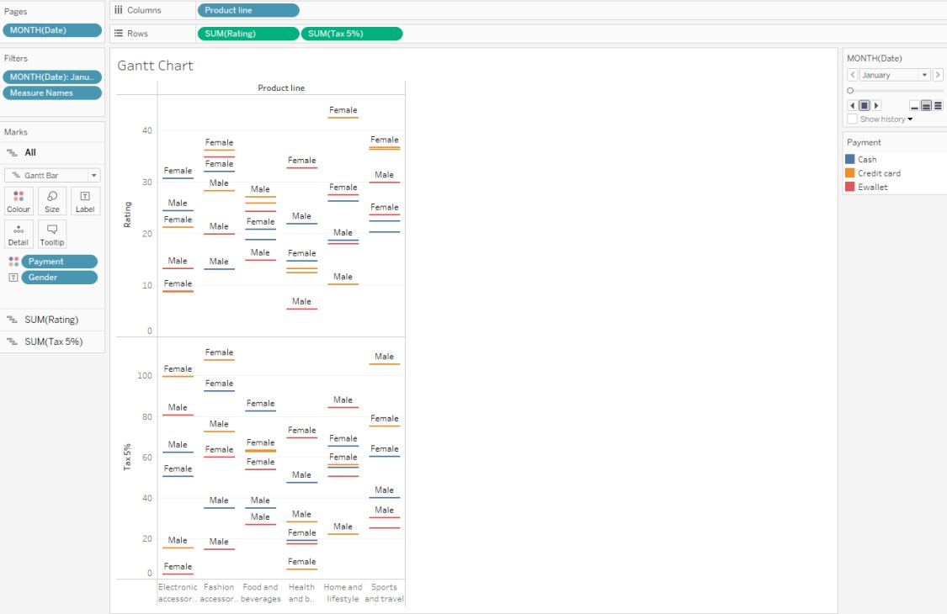

9. Area Plot:



